**Coursework 10**

**Recurrent Neural Networks (RNNs)**

To access the dataset, go to: <https://www.csc.kth.se/cvap/actions/>

Your tasks are as follows:

1. Download Boxing, hand waving, and hand clapping videos and upload them on your drive. The videos are in .avi format with RGB channels. First, convert them to numpy arrays as grayscale frames. You can use ChatGPT to generate a code snippet to do this task. Display 2 frames from a video clips from each class.
2. Implement the network depicted in Figure below with 32 neurons in the hidden layer that is previous to the output layer. Use only two frames/sequences. Report your test accuracy.
3. Implement a network of your choice to increase the test accuracy. Explain your reasoning with a few sentences. 5 teams with highest accuracy get 0.6 points bonus. Following 5 teams will get 0.4 points bonus. Please comply with rules listed below.

Rules:

* Use at least 200 test samples.
* Train your network from scratch at least 5 times and report the average and standard deviation of your test accuracies.
* Do not use long memory units (LSTM, GRU, etc.). You can use SimpleRNN unit in Keras as well as defining the recurrent channel explicitly as done in the sample code provided in Moodle. Note that this code is given as a help and it is not directly usable for question 2.

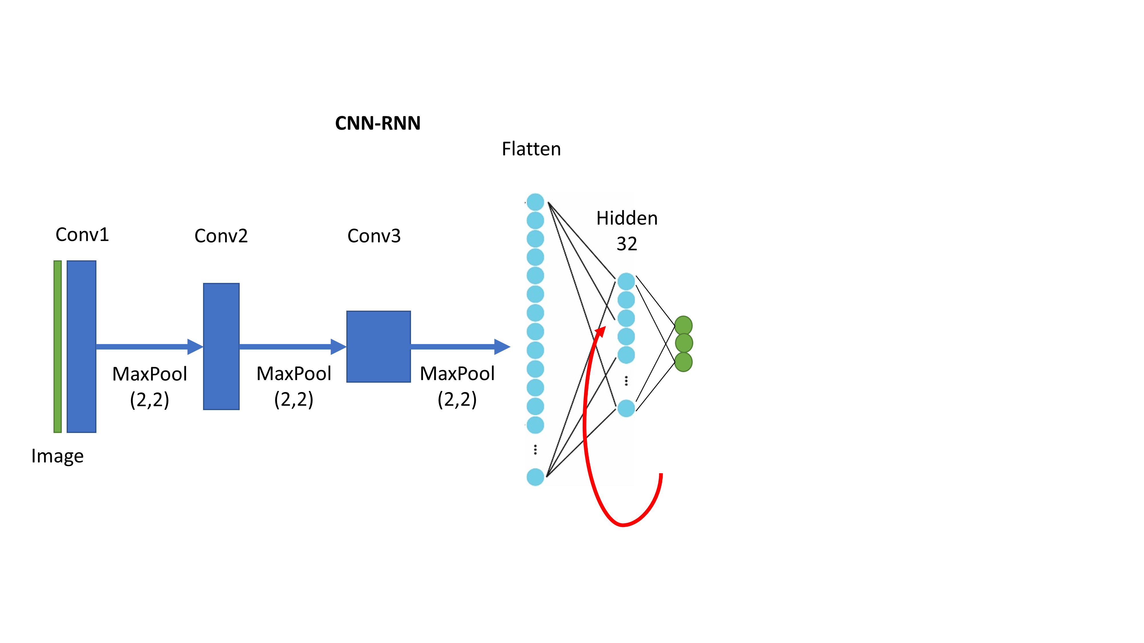

Figure: CNN-RNN architecture.